2018380039_Dikshya Kafle Lab report DBMS

Name: Dikshya Kafle

Student Number: 2018380039

**Experiment 1**

Create and manage database and table

**Goal**

1. Familiar with command line and GUI connection method in MySQL.
2. Master SQL statement to create database and table.
3. Master the update and deletion methods of database and tables.
4. Master the basic methods of backup and restore database.
5. Understand the logical structure and physical structure of MySQL database.

**Content**

1. Use GUI to connect the DBMS
2. Use command line to connect the DBMS
3. Create, backup, drop and restore database and tables through GUI.

* **Database and table**

Database name：SPJ_MNG，four tables in the database：S, P, J, SPJ

S (SNO, SNAME, STATUS, CITY)

P (PNO, PNAME, COLOR, WEIGHT)

J (JNO, JNAME, CITY)

SPJ (SNO, PNO, JNO, QTY)

The supplier table S is composed of supplier code (SNO), supplier name (SNAME), supplier status (STATUS) and supplier city (CITY).

Part list P consists of part code (PNO), part name (PNAME), color (COLOR) and weight (WEIGHT).

Project table J consists of project code (JNO), project name (JNAME) and project city (CITY).

The supply situation table SPJ is composed of supplier code (SNO), part code (PNO), project code (JNO) and supply quantity (QTY). It indicates that the quantity of a certain part supplied by a supplier to an project is QTY.

**S Table**

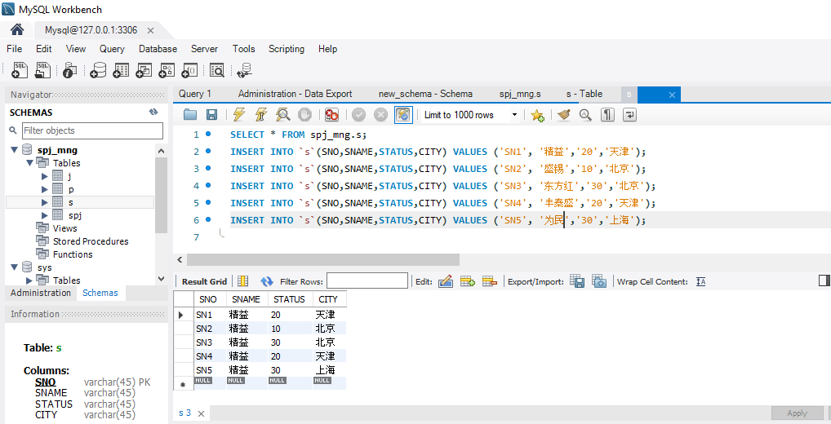

**J Table**

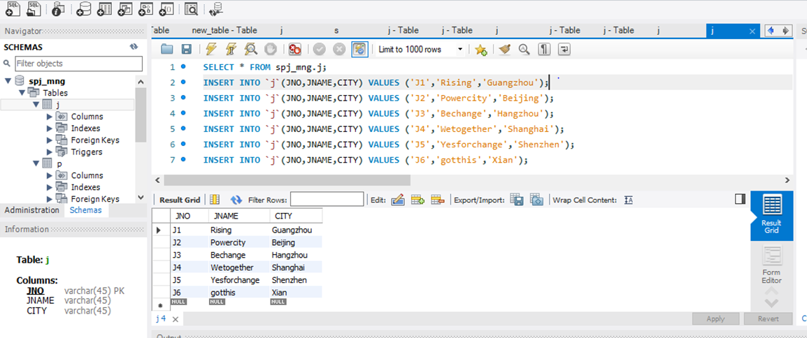

**P Table**

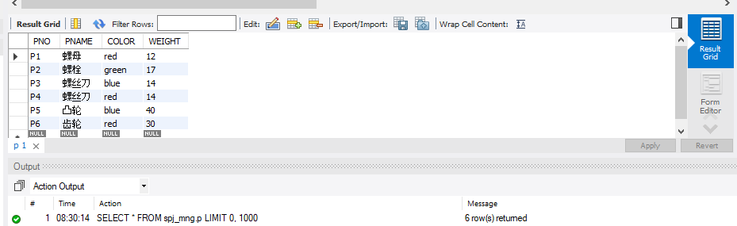

**SPJ Table**

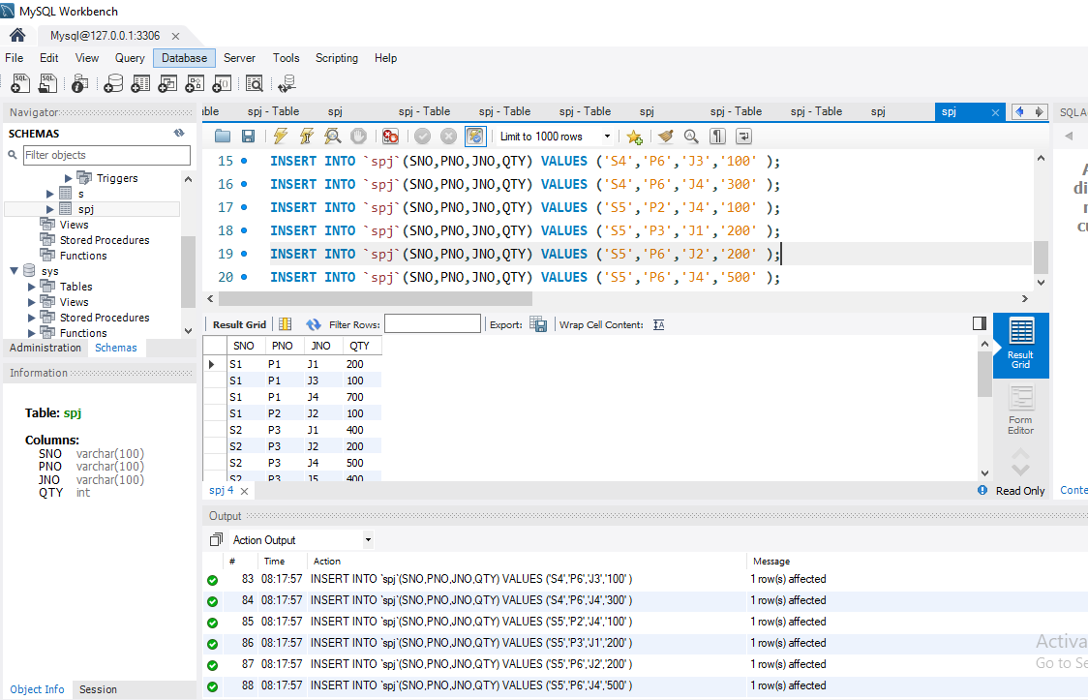

**Restore the database SPJ_MNG with the file you have backed up in previous step**

**Export Database**

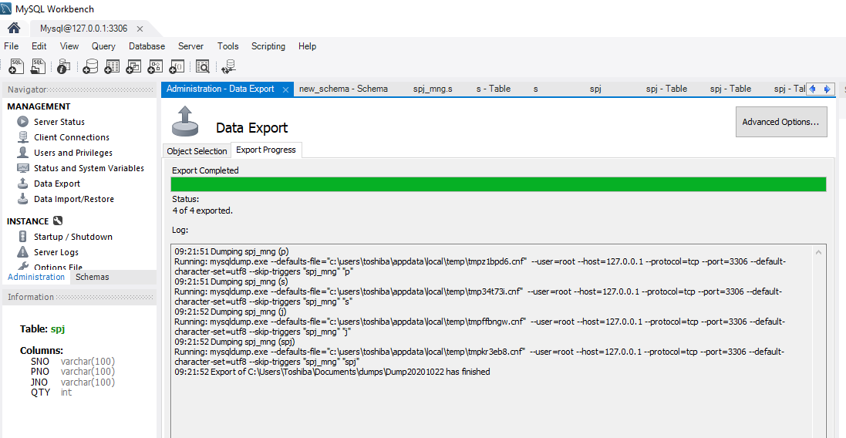

**Import Database:**

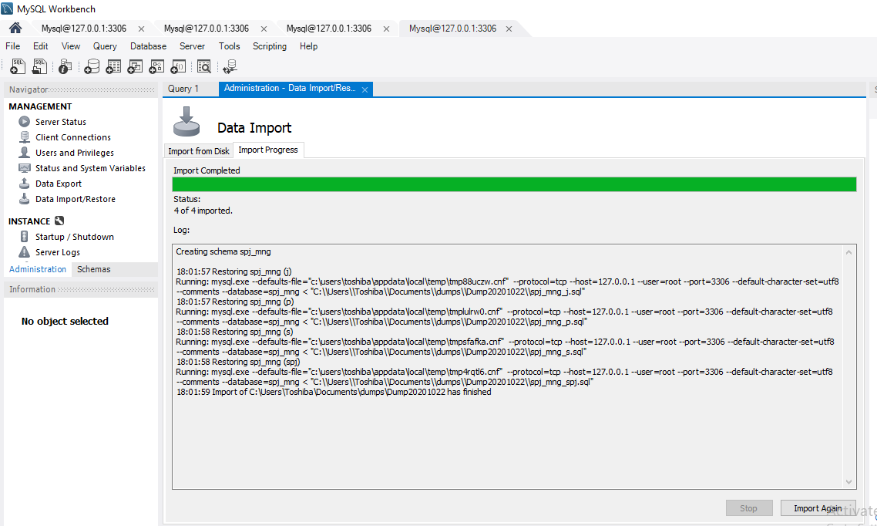

**Imported Tables:**

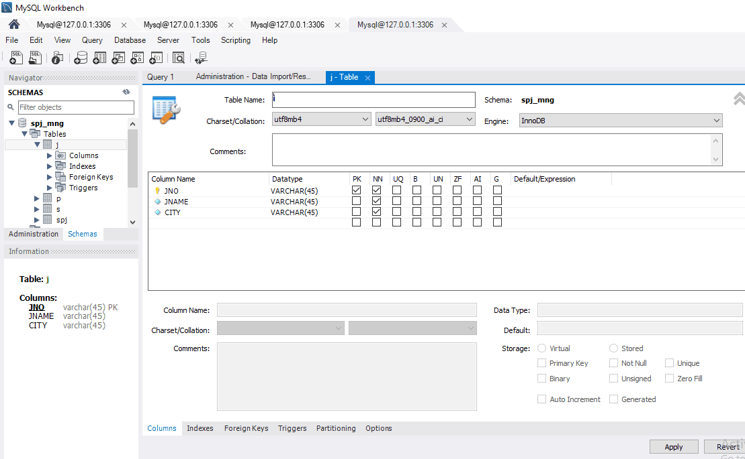

**Restore the database SPJ_MNG with the file have been backed up before**

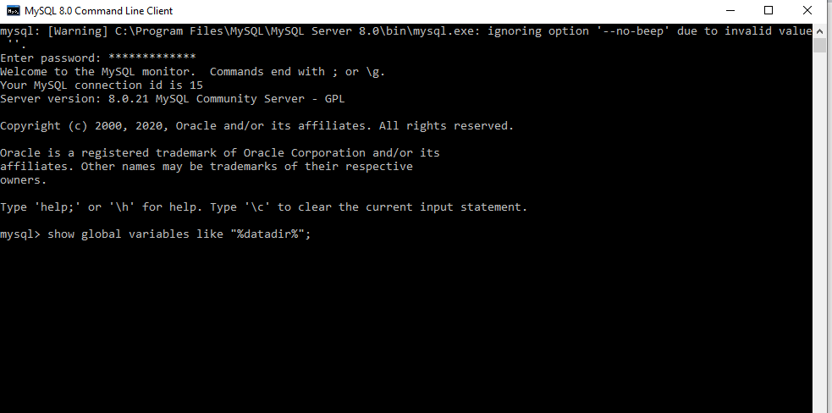

**Updated table S，Add an attribute of contact phone number STEL, the data type is string , and modify the maximum string length allowed by SNO in table S:**

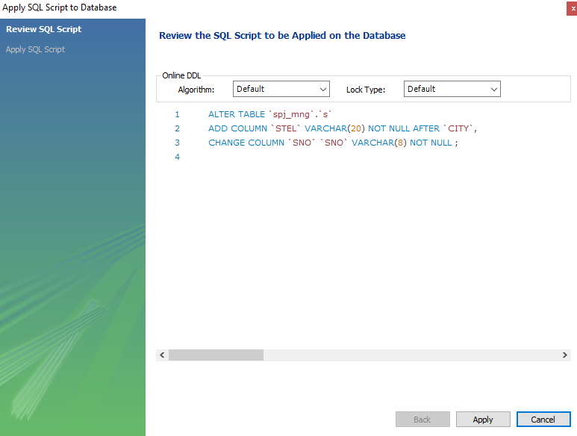

**Understand the physical storage files of MySQL, and check the data files under the local MySQL service installation directory (such as the default installation directory: C: \programdata \ MySQL\ MySQL server 8.0\ data). Try to create tables according to different storage engines of InnoDB and MyISAM, observe and explain the differences of physical storage files.**

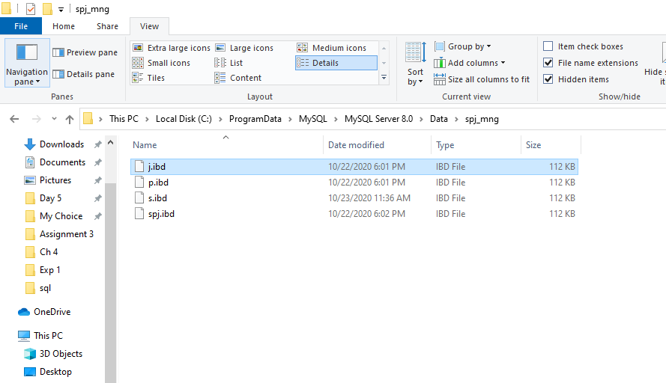

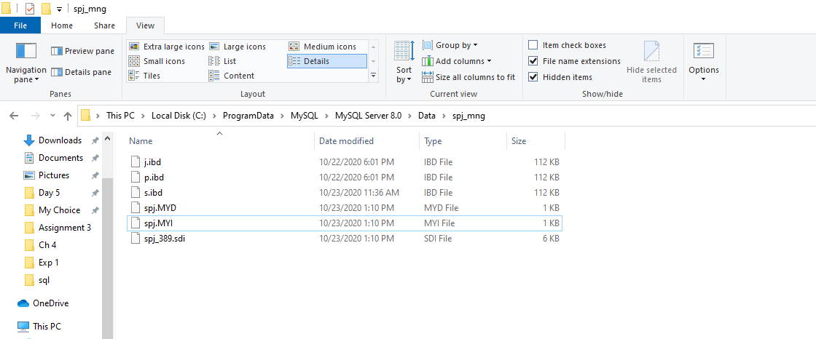

**Create,backup,drop and restore database and table using MySQL command line:**



**SQL statement to create student table by me:**

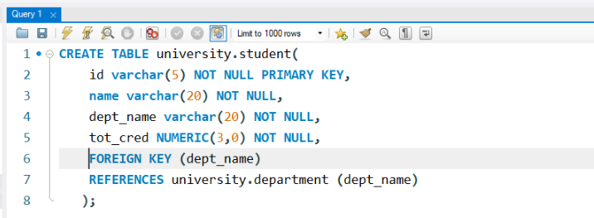

**Auto generated SQL statement for creating student table:**

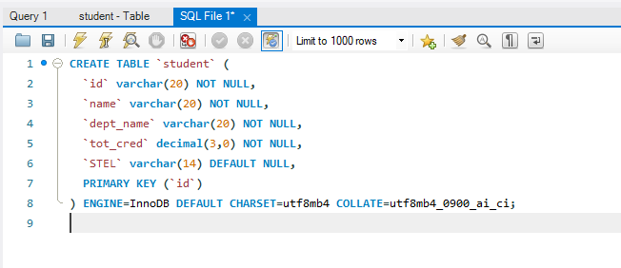

**Comparison of my script vs. the generated script by the system**

* My script only lists the tables and creates attributes and their relation with each other. The generated script consists of more relationships that we are abstract to the users (like null or not null) with more description like Engine, CHARSET, COLLATE. It also has more complex codes difficult to understand on our level.